ONE MINUTE GUIDE
Using FREE CRUK Bowel Screening Cards
- In pharmacy prescription bags
- In GP surgeries

Background – why do this?
NHS Bowel Screening is a national screening programme that checks for signs of bowel cancer. Screening can save lives by detecting early signs of cancer. Everyone aged 60 to 74 who is registered with a GP and lives in England is automatically sent a bowel cancer screening FIT (Faecal Immunochemical Test) kit every two years. The programme is expanding so that everyone aged 50 to 59 years will also be eligible for screening. This is happening gradually over 4 years and started in April 2021 with 56 years. Other age groups will soon be invited.

Cancer Wise Leeds (CWL) has worked with local GP surgeries and wider Primary Care Networks to encourage patients to complete their bowel cancer screening when invited. Since COVID-19, cancer screening and attendance has been affected. As such, CWL have explored new ways of communicating important cancer screening messages to patients. One method already adopted in some areas is to place a bowel cancer screening card into dispensed prescription bags, for patients who are eligible (aged 60 – 74).

Example card from Cancer Research UK (CRUK)
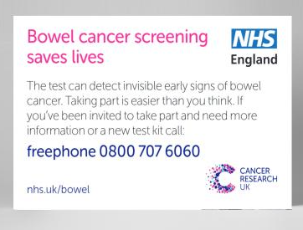

Process
The Pharmacy Technician or another nominated person within the practice can take the lead in contacting all the pharmacies within the practice population area, to invite and encourage pharmacy staff to adopt this routine of adding cards to prescription bags. Once ordered from CRUK, simply add bowel screening cards into patient prescription bags for patients aged 60 – 74. There is no need to put cards in prescription bags for patients under 60yrs at this stage. The bowel screening cards can also be ordered and used within the GP practice by reception and other practice staff, to engage in opportunistic conversations with patents of eligible screening age.

Ordering cards (FREE OF CHARGE)
To order bowel screening cards visit the following website. The cards are free to order and to deliver here.

