Guidance for Leeds Primary Care General Practices on SystmOne Bowel Cancer Screening Template and Reports

Table of Contents
Bowel Cancer Screening Programme 2
Bowel Cancer Screening Template 3
Bowel Cancer Screening clinical Codes 5
Bowel Cancer Screening (BCS) Reports 6
Exclusion Criteria 9
Bowel Cancer Screening Resources 9

Bowel Cancer Screening Programme

This guidance document has been created to identify the resources and tools available for practices participating in the bowel cancer screening programme. The below timeline provides a simplified overview of the bowel cancer screening process and identifies where practice participation is required:
Advice given about bowel cancer screening programme
The programme hub will offer bowel cancer screening tests directly to patients aged 60-74. Prior to this contact, GP practices will need to provide patients with information about the bowel cancer screening programme in the month before they turn 60.

To do this GP Practices will need to run a monthly report to identify patients that are due to turn 60 in the next month (go to page 5 for report info/location). Once these patients have been identified and the information has been provided to the patient, the practice should add ‘Advice given about bowel cancer screening programme’ (XaPyB) to their record.

No response to bowel cancer screening invitation
Once the hub has invited a patient to complete their bowel screening kit they will wait 13 weeks for a response. If the kit is not returned or the patient does not respond to their bowel screening invitation they will be counted as a ‘non-responder’ by the hub. The hub will notify the practice by sending a pathology report to the practice which will add the Read code ‘No response to bowel cancer screening programme invitation’ (XaPf6)’ to the patients record once actioned.

Practices contact non-responders to complete bowel cancer screening
Once a patient has been identified as a ‘non responder’ you will need to contact the patient and invite them to complete their bowel cancer screening kit, this should be done by one of the following; telephone invitation, letter invitation, SMS invitation or face to face. Please note patients should be invited to complete the screening 3 times (one contact per month).
A work to do report has been created to help practice identify this cohort of patients. Please go to page5 for report info/location. Please note, once a patient has completed their screening they will be removed from the WTD report.

Bowel cancer screening declined
If a patient no longer wants to participate add the ‘bowel cancer screening declined’ Read code to the patients record.

Bowel Cancer Screening Template

The bowel cancer screening template is called ‘Bowel Cancer Screening Advice/Contact HCH’. Please ensure this is added to your clinical tree, if you are unsure how to do this please contact the CCG Data Quality Team (leedsccg.dataqualityteam@nhs.net).
The template includes Read codes used for reporting, letter templates, SMS examples and useful web links to provide further guidance and information to patients. There is also a view to help users identify when a patient was last contacted and which method was used, the view will also include any accessible information Read codes (such as spoken language) so will support users in selecting the most appropriate contact method.
Page One
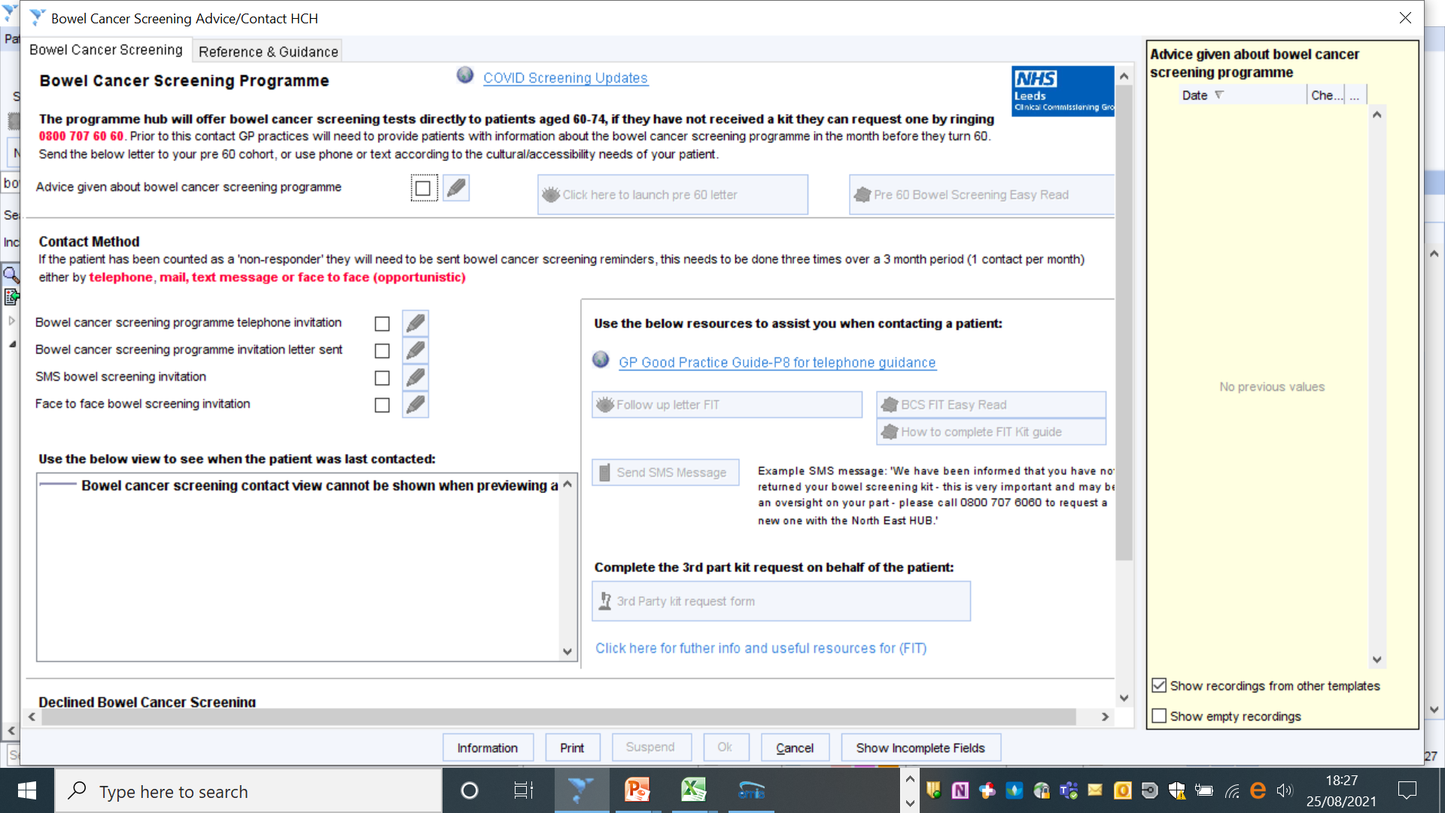

Page 2
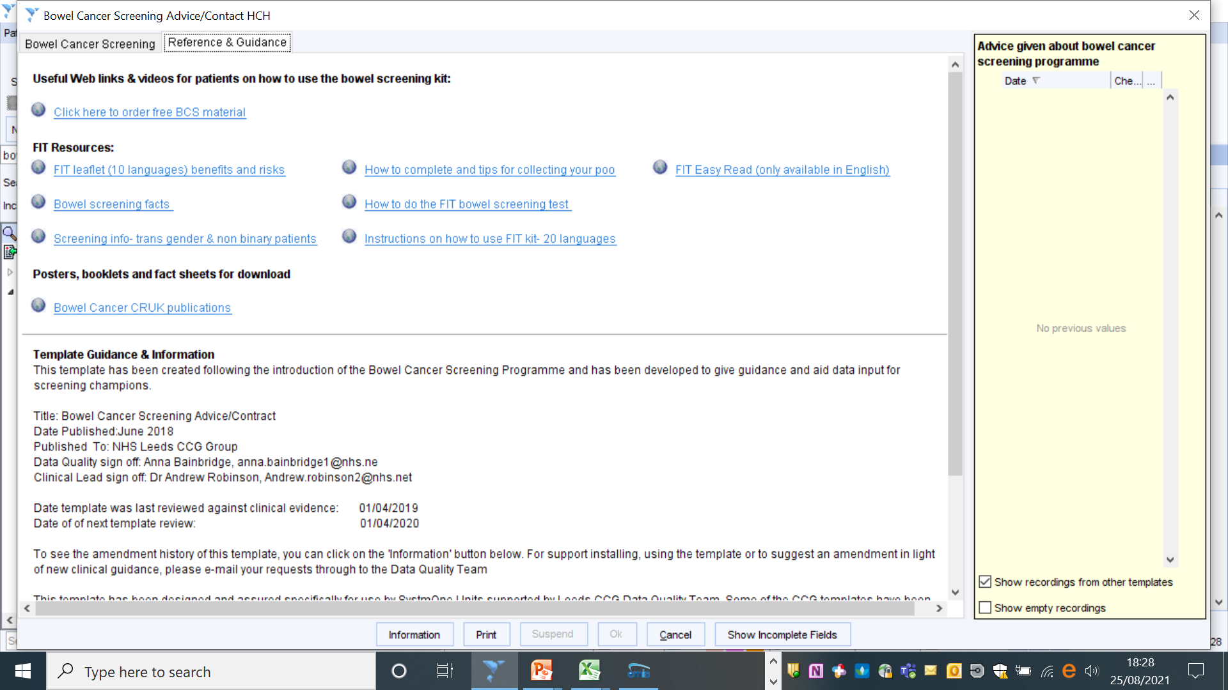

Bowel Cancer Screening Kit Request Letter
If a patient wishes to participate in the programme but does not have a test kit one can be requested on their behalf. Please use the ‘Third Party Kit Request Letter’. This letter can be accessed via the link in the template (see below) . The letter will populate with the patient’s details and can be emailed to the hub who will then send the patient a kit directly.

Bowel Cancer Screening Read Codes

The Read codes identified in the below table have been incorporated within the clinical template they will also be used in the reports to help support the programme evaluation:
SystmOne Read Code | Snomed | Description
XaPyB | 382161000000102 | Advice given about bowel cancer screening programme  - Use for any pre 60 contact to confirm that patient has been given information
XaZx4 | 862011000000104 | Bowel cancer screening programme telephone invitation
XaZx5 | 862031000000107 | Bowel cancer screening programme invitation letter sent
XaIej | 24431000000100 | Message given to patient  - Use this Read code when patients are contacted by SMS text
9O23. | 185536007 | Verbal invite to screening (face to face invitation)  - Only use if you have given specific face to face advice to patient about bowel screening completion.
XaN4r | 294201000000109 | Bowel cancer screening declined  - If patient no longer wants to participate ( Resulting in 2 years opt out and excluding them in the Work To Do reports)
XaZu9 | 860781000000108 | Provision of information about bowel cancer screening programme

Please ensure that the correct codes are used, failure to use the codes suggested as part of the programme will have an impact on the reports extracted for the programme evaluation.

Bowel Cancer Screening (BCS) Reports

Performance Reports
Location: Reporting > Clinical Reporting > Leeds Data Quality; Cancer Screening Programme data quality; BSC performance
The following performance reports will be used for the programme evaluation:
-Performance -Number of eligible patients who have not responded to bowel cancer screening
-Performance -How many patients were consequently contacted by the practice to encourage completion of screening?
-Performance - How many patients contacted went on to complete bowel screening?

Work To Do Reports

Location: Reporting > Clinical Reporting > Leeds Data Quality; Cancer Screening Programme data quality; BCS WTD
1) Patients due to turn 60/excluding patients that are not eligible: This report should be run monthly. Patients that are identified within this report should be sent a ‘Pre 60 letter’ (available within the template) with the ‘Advice given about bowel cancer screening programme’ Read code added to their record.
2) WTD - Non-responder, without any contact codes, without BCS result: This report will help identify patients that have NOT been contacted/invited to complete BCS by the practice. Patients within this report should be invited to complete bowel screening three times either by SMS, telephone, letter or face to face (see required contact codes below):
-Bowel cancer screening programme telephone invitation (XaZx4) 862011000000104
-Bowel cancer screening programme invitation letter sent (XaZx5) 862031000000107
-Message given to patient (XaIej) 24431000000100
- Verbal invite to screening (9O23.) 185536007

3) WTD - Non-responders, that have been contacted by the practice but do NOT have a BCS result recorded: This report will help identify patients that HAVE been contacted/invited to complete BCS by the practice, however have not gone on to complete screening. You can breakdown this report to assess how many times a patient has been invited (patients should be contact 3 times by the practice). Use the guidance below to help breakdown this report:
-Right click on the ‘ 2) WTD - Non-responders, that have been contacted by the practice without at BCS result coded’ and select ‘Breakdown Results’:
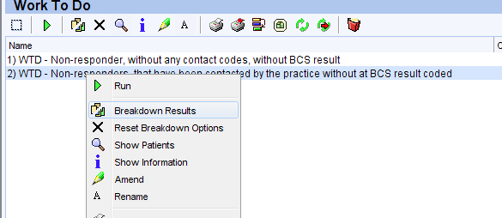
-From the selection list on the left hand side, open up the demographics tab and tick ‘First Name, Surname and NHS Number’.
-The scroll down to the folder labelled ‘Patient contacted by practice 2021 22 (Bowel Cancer Screening / Z reports)’, copy /tick the boxes from the below screenshot:
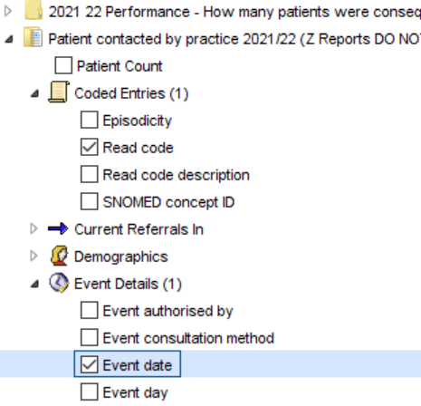

-Click the refresh button (this is at the top of the left hand panel), once you have clicked refresh the report will retrieve a list of patients on the right hand side.
-You can use the breakdown report to work out how many times a patient has been contacted/invited to bowel screening, for example if a patient has two separate Read code entries in the report this means they have been contacted twice and will need to be contacted one more time.
-To export the breakdown report into an excel spreadsheet, click on

Bowel Cancer Screening (BCS) Target Group Reports

There are a group of reports to support practices to target specific patient groups. These are those who are BAME, those on the Learning Disability register and those on the Mental Health Register. This will enable these patients to receive bespoke invitations. These reports are based on the WTD reports described on page 9.
Location: Reporting > Clinical Reporting > Leeds Data Quality; Cancer Screening Programme data quality; BCS WTD
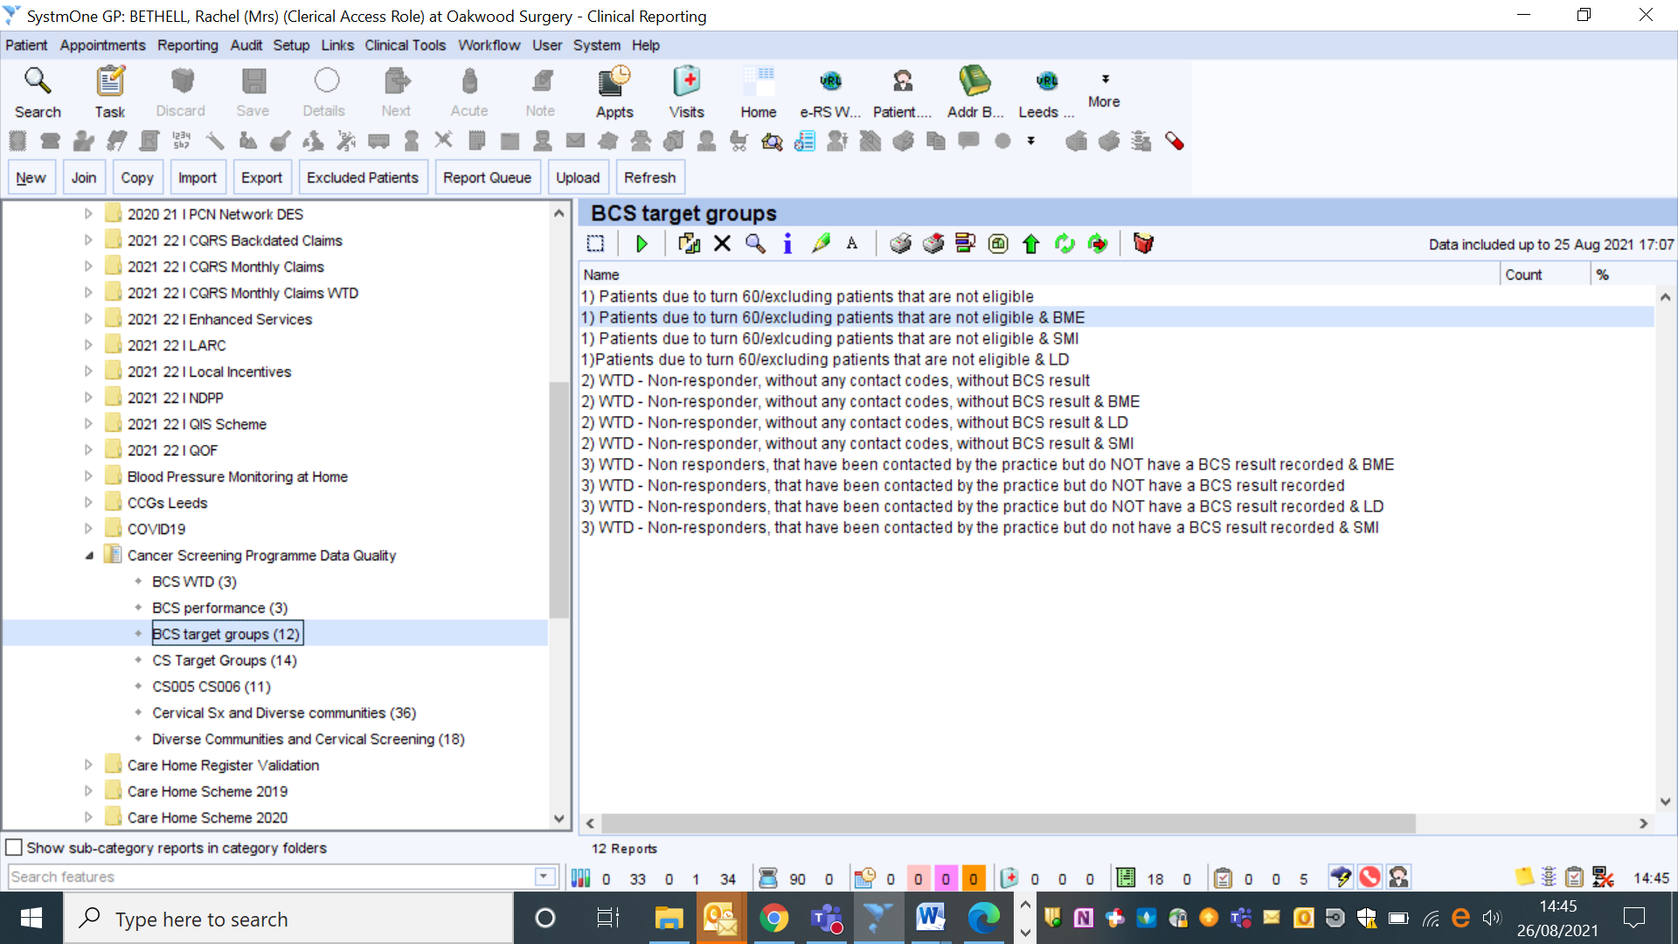

Exclusion Criteria

CRUK Review lists to exclude patients for whom it may be insensitive for the practice to endorse in screening. However, please note they will still be invited by the national screening programme:
-Colonoscopy in the last 2 years
-Opted out of screening/bowel cancer screening declined code recorded in the last 2 years
-Palliative
-Bowel cancer
-Chronic inflammatory bowel disease
-Are coded as ineligible

Bowel Cancer Screening Resources
For technical support with the template or reports please contact leedsccg.dataqualityteam@nhs.net
CRUK GP Good Practice Guide: http://www.cancerresearchuk.org/health-professional/screening/bowel-screening-evidence-and-resources/bowel-screening-resources#BowelScreeningResources0

CRUK publications website where you can order free material:
https://publications.cancerresearchuk.org/taxonomy/term/4216
PHE bowel screening facts: https://www.gov.uk/government/publications/bowel-cancer-screening-benefits-and-risks
The languages have been taken away for some reason – this needs deleting

PHE Bowel Cancer screening kit: how to use instructions:
https://www.gov.uk/government/publications/bowel-cancer-screening-kit-how-to-use

NHS leaflet “A easy guide to bowel cancer screening” This leaflet uses illustrations to explain the bowel screening test and is a leaflet by and for people with learning disabilities/for those where English is their second language
https://assets.publishing.service.gov.uk/government/uploads/system/uploads/attachment_data/file/598296/easy_guide_bowel_cancer_screening.pdf

Public Health new leaflet order form: https://www.leeds.gov.uk/phrc/resources/leaflets-and-posters PHRC supply the LCC/NHS leaflet “These 3 items could save your life” and the CRUK leaflet “Know your body spot cancer early”

How to use the kit, Dr Rob Eastham video http://www.facebook.com/screeninginfo

Links to videos promoting bowel screening and addressing some of the barriers to take up with the Asian community:
https://www.youtube.com/watch?v=P1Ry1zXIjkA (Urdu)
https://www.youtube.com/watch?v=CHIvdwOqrQs (Bengali)
https://www.youtube.com/watch?v=KOcI7-oN4DY (Gujrati)

