October – Breast Cancer Awareness Month Social Media Posts

The following information provided by Leeds Health Awareness (previously known as Leeds Cancer Awareness) can be used to engage with patients and raise awareness during Breast Cancer Awareness Month in October. This can be done using practice websites, social media platforms and information TV screens.

Post 1
October is Breast Cancer Awareness Month! This month we will post once a week about different aspects of breast cancer. Everyone has breast tissue; around 54,700 people are diagnosed with breast cancer every year in the UK. If breast cancer is diagnosed at stage 1 around 98% will survive their cancer for five years or more.
For more information visit, https://www.cancerresearchuk.org/about-cancer/breast-cancer

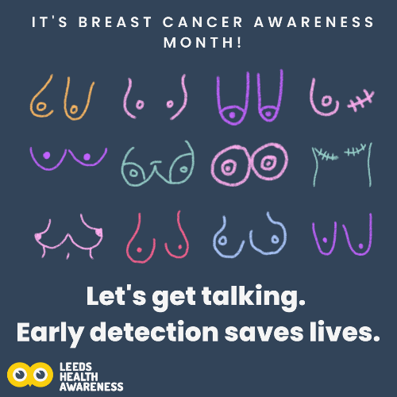

Post 2
You know your body best! If you notice any unusual changes, speak to your GP and book an appointment. You are not wasting anyone’s time. If you do see or feel any changes to your breasts/pecs it does not necessarily mean you have breast cancer, but it is always best to get checked and find out the cause.
To learn more about potential signs and symptoms visit https://www.knowyourlemons.com/.
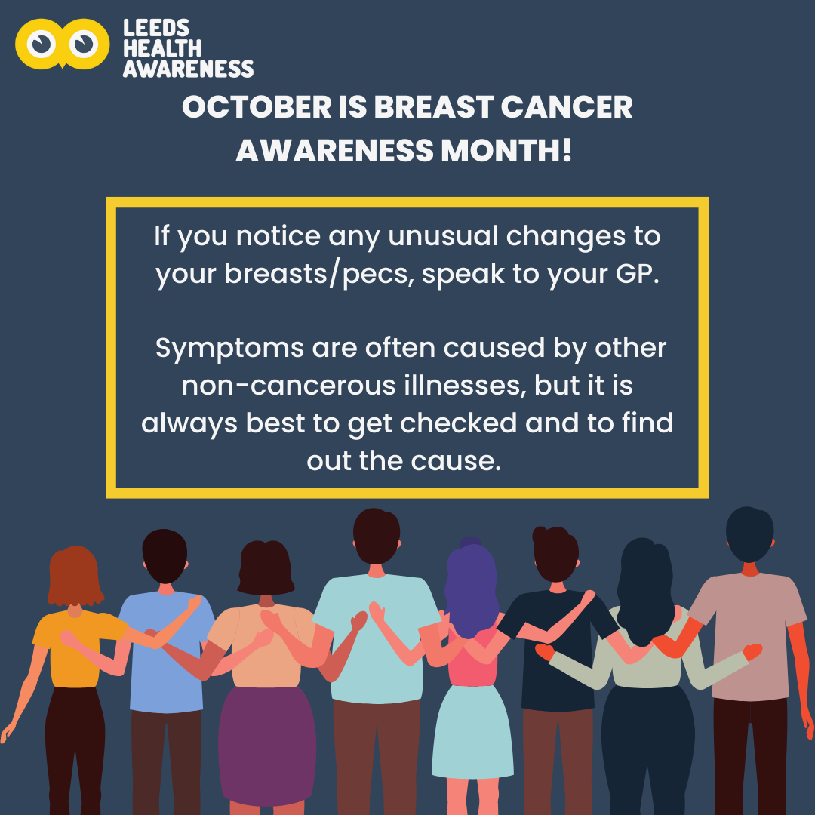

Post 3
Everyone has breast tissue! Don't forget to self-check your breasts/pecs regularly, we recommend once a month. There is no right or wrong way to do it but if you are unsure watch this video https://vimeo.com/298985447.
Remember, you are not just feeling for lumps, you are feeling and looking for any unusual changes. If you do spot any changes to your breasts speak to your GP. Symptoms are often caused by other non-cancerous illnesses, but it is always best to get checked. For more information, visit https://www.cancerresearchuk.org/about-cancer/breast-cancer. Early detection saves lives.

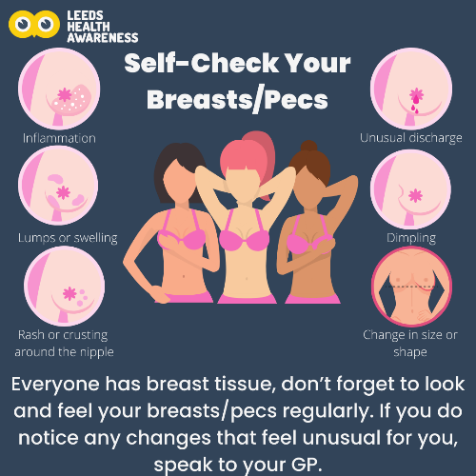

Post 4
Breast screening is an x-ray called a mammogram; it aims to find breast cancer at an early stage. In the UK women, some trans and non-binary people aged 50-71 are eligible for breast screening. If you are registered with a GP, you should be sent a letter to book in your mammogram every 3 years. It may be that you do not receive your letter the year you turn 50, but you should receive the letter by 53.
If you are trans or non-binary and are unsure of your eligibility visit https://www.cancerresearchuk.org/about-cancer/cancer-symptoms/spot-cancer-early/screening/trans-and-non-binary-cancer-screening
Early detection saves lives.
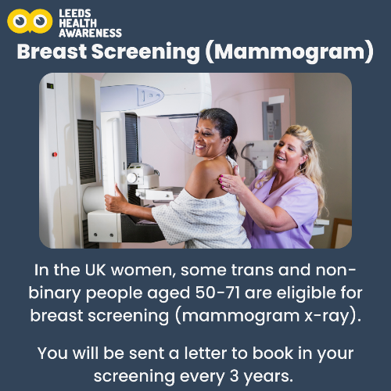
Post 5
During your breast screening (mammogram) appointment a female mammographer will carry out your mammogram. You will be asked to undress to the waist and stand in front of the mammogram machine. Breasts will be scanned one at a time, you will be positioned so that the best scan of your breast can be taken. You should get your results within 2 weeks.
Remember, screening is routine if you notice any unusual changes to your breasts speak to your GP.
For more information about breast screening, visit https://breastcancernow.org/information-support/facing-breast-cancer/what-expect-breast-clinic-appointment/breast-screening
