

**Cervical Screening & Hysterectomy – June 2021 (updated August 2021)**

**Auditing records of patients coded with total hysterectomy**

In light of the hysterectomy coding issue in Scotland ([Woman dies after Scottish cancer screening error - BBC News](https://www.bbc.co.uk/news/uk-scotland-57596250) / <https://www.jostrust.org.uk/about-us/news-and-blog/blog/behind-headlines-cervical-screening-incident-scotland-and-what-it-means>), where 430 women had undergone partial hysterectomies (sub-total hysterectomies) and had subsequently been removed from the Scottish Cervical Screening Programme, it was recommended that practices audit their patient records to ensure they are accurate. There was a response from the National Cervical Screening programme and the National Call/Recall team issued a mandatory audit. The national audit had to be completed by October 2021.

It is recommended that practices review their patients coded with a NOCX (no cervix) code. This review will ensure that the QOF Cervical Screening Denominator (register) is accurate. Patients may have joined the practice having already been coded with a total hysterectomy so, even if a practice is confident in their own process for coding, it is advisable to review all hysterectomy patients periodically.

Practices should ensure that they have robust procedures in place for ceasing women for a ‘no cervix’ reason from the National Call/Recall Cervical Screening Programme. The decision to submit a ceasing form for ‘no cervix’ should only be made after a clinician has reviewed the correspondence from secondary care and is satisfied that a total hysterectomy has been performed and there is no ambiguity around whether a patient has retained their cervix.

Further information on ceasing women from the National Cervical Screening Programme can be found here; <https://www.csas.nhs.uk/support/>

After undergoing a sub-total hysterectomy, patients should remain in the national call/recall system for Cervical Screening, but incorrect coding on the clinical system may have excluded them inappropriately from the QOF Cervical Screening indicators. If this is the case, then patients may miss out on opportunistic invites based on QOF status alerts and additional text/letter invites based on the QOF cervical screening ‘Missing Patients’ reports.

**To support practices with this work there are two clinical system reports available:**

CS005 – coded with complete removal of cervix (this is looking at women aged 25-49 who have a NOCX (no cervix) code on their record).

CS006 – coded with complete removal of cervix (this is looking at women aged 50-64 who have a NOCX (no cervix) code on their record).

Practices should review the individual records of patients in the reports CS005 – complete removal of cervix and CS006 – complete removal of cervix. The hysterectomy coding in the patient record should be reviewed against the information received from secondary care regarding the hysterectomy operation. The coding of the hysterectomy should exactly match the description of the operation in the letter. Any discrepancies should be reviewed by a clinical member of staff and appropriate action taken.

The reports **CS005 – complete removal of cervix** and **CS006 – complete removal of cervix** are based on the QOF cluster code NOCX (no cervix codes).

Once a code from the NOCX cluster is recorded on a patient record it will remove the patient from the QOF Cervical Screening Denominator (Register). This means that the patient will not appear in the QOF ‘Missing Patient’ reports and QOF Cervical Screening status alerts will not show. ***Please note that recording a NOCX code on a patient record will not automatically remove them from the National Cervical Screening Programme****.* The administration of the National Cervical Screening Programme Call/Recall is carried out using the ‘Open Exeter’ System not the GP Clinical Systems and there is a specific process for removing a patient from the National Cervical Screening Programme. The ‘Open Exeter’ system is used for ceasing women when they have no cervix. A form needs to be completed and have clinical sign off. A copy of the form should be saved onto the patient record.

*Please note that these reports may not pick up women who have been ceased from the national call/recall programme. The process of ceasing from the national programme is based on the completion of the ‘Ceasing from the Cervical Screening Programme’ form and not based on coding with the GP clinical systems. Practices should review their systems for ceasing women and carry out additional audit processes if required.*

Location of the reports - For SystmOne users the reports can be found in the following location - Reporting; Clinical Reporting; Leeds Data Quality; Cancer Screening Programmes Data quality; CS005 CS006

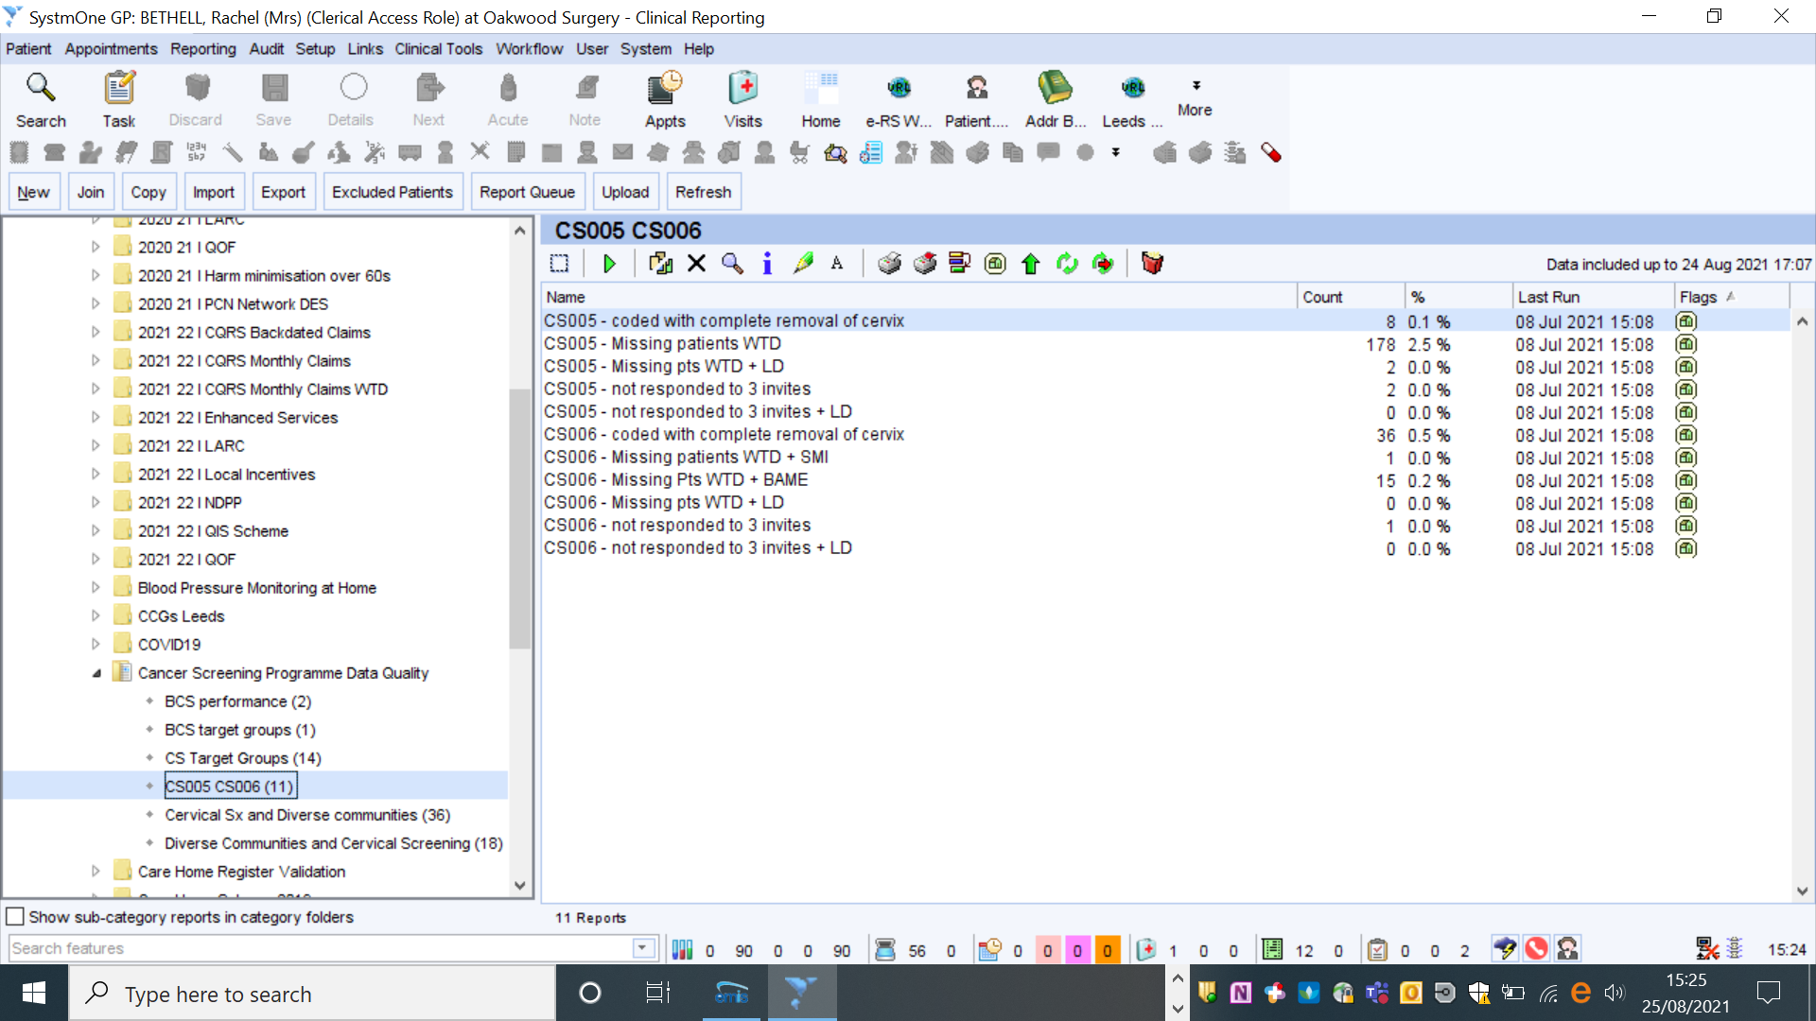

For EMIS users the reports are available centrally via the CCG (Clinical Commissioning Group) extranet [Login – NHS Leeds CCG Primary Care Extranet](https://primarycare.leedsccg.nhs.uk/login/?redirect_to=https://primarycare.leedsccg.nhs.uk/resources/leeds-cancer-wise-cs005-cs006-reports-emis/) or via the Data Quality Team [leedsccg.dataqualityteam@nhs.net](mailto:leedsccg.dataqualityteam@nhs.net)

For EMIS users the reports are also available in the CCG resource publisher

Leeds Data quality; Cancer Screening Programme; Cervical Screening WTD.

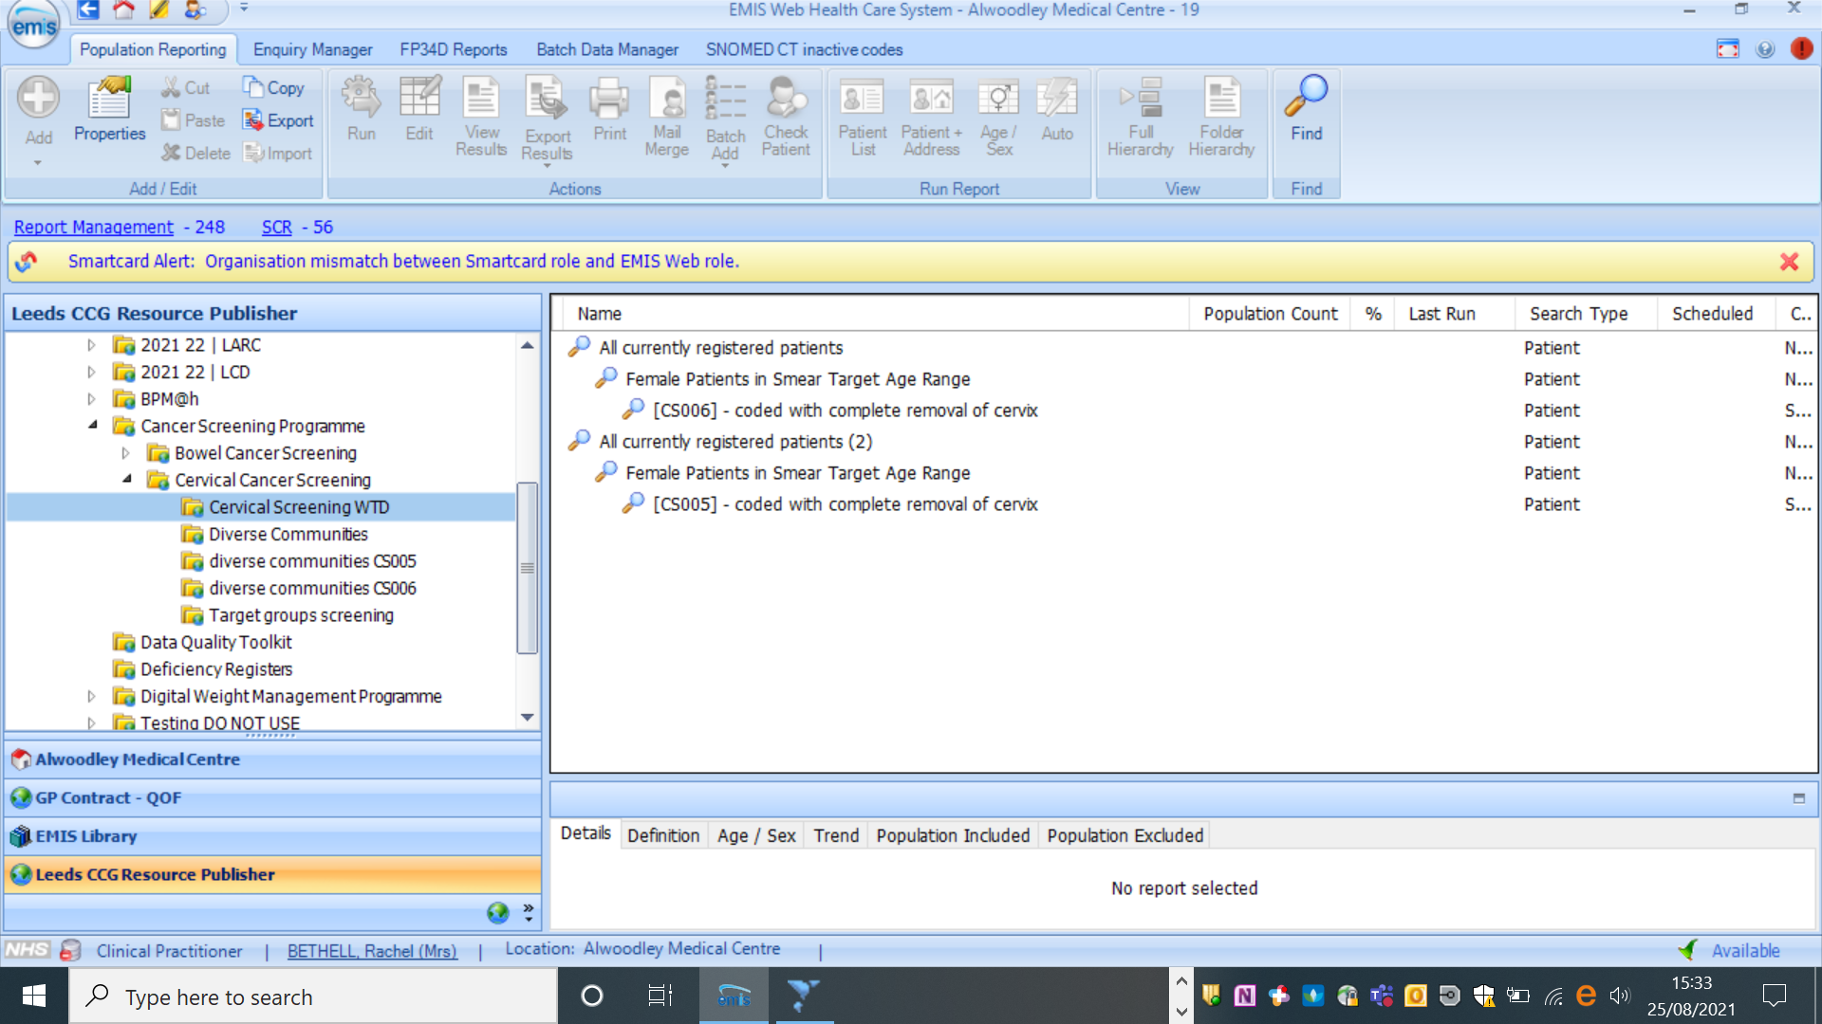

For technical support with reports and codes please contact: [leedsccg.dataqualityteam@nhs.net](mailto:leedsccg.dataqualityteam@nhs.net)

**Total Hysterectomy**

Women who have had total hysterectomy will have had their cervix removed; are no longer eligible for cervical screening and should not receive any more screening invitation letters. The Cervical Screening Administration Service (CSAS) form ‘Ceasing from the Cervical Screening Programme’ should be completed.

**Sub-total hysterectomy**

This is an operation where the body of the uterus is removed but the cervix is left. It is sometimes referred to as a partial hysterectomy. Patients need to continue to remain in the Cervical Screening Programme and have regular smears.

**Ceasing from the Cervical Screening Programme**

The Cervical Screening Administration Service (CSAS) form ‘Ceasing from the Cervical Screening Programme’ should be completed when a patient has a total hysterectomy and only by a clinical member of staff. When choosing the ‘No Cervix’ option the clinician completing the form should ensure that they have reviewed the paperwork from secondary care and it is clear that a total hysterectomy has been performed and the patient no longer has their cervix in situ. A copy of this form should be saved to the patient record.

**QOF Cervical Screening Indicators**

It is important that the appropriate hysterectomy code is used on the patient record. If a patient is incorrectly coded with a code from the ‘NOCX (no cervix) code cluster’ then they will not appear in the QOF denominator for Cervical Screening. This means that QOF alerts for Cervical Screening will not be flagged on a patient’s record, opportunistic invites will be missed and the patient will not appear in the QOF Cervical Screening Indicator ‘Missing Patients’ report. The NOCX cluster codes can be found in Appendix A.

**Coding Queries**

When the correspondence from secondary care regarding hysterectomy treatment does not clearly state what type of hysterectomy has been carried out (and whether patient has retained their cervix) then the practice should seek clarification.

**Vault smears**

Women who need vaginal vault sampling following surgery are not included in the NHS Cervical Screening Programme. Vault samples should be taken in a hospital setting only and therefore women requiring this should be referred to colposcopy or remain at colposcopy until all necessary vault samples have been taken. The laboratory will reject vault samples taken in primary care.

Appendix A – Snomed Codes that indicate total removal of the cervix (NOCX_COD code cluster list)

|  |  |
| --- | --- |
| **SNOMED concept ID** | **Code description** |
| 10738891000119107 | History of total hysterectomy without abnormal cervical Papanicolaou smear (situation) |
| 116142003 | Radical hysterectomy (procedure) |
| 116143008 | Total abdominal hysterectomy (procedure) |
| 116144002 | Total abdominal hysterectomy with bilateral salpingo-oophorectomy (procedure) |
| 171167004 | No smear-amputation of cervix (finding) |
| 171169001 | No smear - no cervix (finding) |
| 180055000 | Anterior exenteration of pelvis (procedure) |
| 180056004 | Posterior exenteration of pelvis (procedure) |
| 236888001 | Laparoscopic total hysterectomy (procedure) |
| 236890000 | Classic SEMM laparoscopic hysterectomy (procedure) |
| 236891001 | Laparoscopic radical hysterectomy (procedure) |
| 248911005 | Uterine cervix absent (finding) |
| 265056007 | Vaginal hysterectomy (procedure) |
| 268544001 | No smear - benign hysterectomy (finding) |
| 307771009 | Radical abdominal hysterectomy (procedure) |
| 309879006 | Abdominal hysterocolpectomy (procedure) |
| 309880009 | Vaginal hysterocolpectomy (procedure) |
| 35955002 | Radical vaginal hysterectomy (procedure) |
| 361222003 | Wertheim-Meigs abdominal hysterectomy (procedure) |
| 361223008 | Wertheim operation (procedure) |
| 413145007 | Vaginal hysterectomy with conservation of ovaries (procedure) |
| 414575003 | Laparoscopic total abdominal hysterectomy and bilateral salpingo-oophorectomy (procedure) |
| 416099005 | No cervical smear required - no uterus (finding) |
| 441820006 | Laparoscopy assisted vaginal hysterectomy with bilateral salpingo-oophorectomy (procedure) |
| 446446002 | Total abdominal hysterectomy and removal of vaginal cuff (procedure) |
| 446679008 | Total laparoscopic excision of uterus by abdominal approach (procedure) |
| 447771005 | Abdominal hysterectomy and excision of periuterine tissue (procedure) |
| 448539002 | Vaginal hysterectomy and excision of periuterine tissue (procedure) |
| 52224004 | Pelvic exenteration (procedure) |
| 708877008 | Laparoscopic total hysterectomy using robotic assistance (procedure) |
| 708878003 | Laparoscopic radical hysterectomy using robotic assistance (procedure) |
| 71911000119106 | No vaginal Papanicolaou smear required due to history of hysterectomy (situation) |

|  |  |
| --- | --- |
| 739671004 | Total hysterectomy with left oophorectomy (procedure) |
| 739672006 | Total hysterectomy with right oophorectomy (procedure) |
| 739673001 | Total hysterectomy with left salpingo-oophorectomy (procedure) |
| 739674007 | Total hysterectomy with right salpingo-oophorectomy (procedure) |
| 740514001 | Total hysterectomy with right salpingectomy (procedure) |
| 740515000 | Total hysterectomy with left salpingectomy (procedure) |
| 75835007 | Laparoscopic-assisted vaginal hysterectomy (procedure) |
| 762625001 | Vaginal hysterectomy and pelvic floor repair (procedure) |
| 767610009 | Total hysterectomy via vaginal approach (procedure) |
| 767611008 | Total abdominal hysterectomy using intrafascial technique (procedure) |
| 767612001 | Total hysterectomy via vaginal approach using intrafascial technique (procedure) |
| 86477000 | Total hysterectomy with removal of both tubes and ovaries (procedure) |
| 88144003 | Removal of ectopic interstitial uterine pregnancy requiring total hysterectomy (procedure) |
| 918451000000102 | Vaginal hysterectomy and right salpingo-oophorectomy (procedure) |
| 918471000000106 | Vaginal hysterectomy and left salpingo-oophorectomy (procedure) |
| 918491000000105 | Radical hysterectomy with conservation of ovaries (procedure) |
| 918511000000102 | Radical hysterectomy with bilateral salpingo-oophorectomy (procedure) |
| 37687000 | Congenital absence of cervix (disorder) |
| 708985003 | Laparoscopic vaginal hysterectomy using robotic assistance (procedure) |
| 608805000 | Laparoscopic assisted vaginal hysterectomy with repair of cystocele (procedure) |
| 608807008 | Laparoscopic assisted vaginal hysterectomy with repair of cystocele and rectocele (procedure) |
| 608806004 | Laparoscopic assisted vaginal hysterectomy with repair of rectocele (procedure) |
| 55853002 | Pelvic exenteration, female (procedure) |
| 446433007 | Anterior exenteration of female pelvis (procedure) |
| 72261007 | Resection of rectum with pelvic exenteration (procedure) |
| 699789005 | Vaginal hysterectomy with repair of cystocele and rectocele (procedure) |
| 54490004 | Vaginal hysterectomy with repair of enterocele (procedure) |
| 27185000 | Vaginal hysterectomy with partial colpectomy and repair of enterocele (procedure) |
| 30160001 | Vaginal hysterectomy with total colpectomy and repair of enterocele (procedure) |
| 77902002 | Vaginal hysterectomy with partial colpectomy (procedure) |
| 27185000 | Vaginal hysterectomy with partial colpectomy and repair of enterocele (procedure) |
| 30160001 | Vaginal hysterectomy with total colpectomy and repair of enterocele (procedure) |
| 43791001 | Vaginal hysterectomy with total colpectomy (procedure) |
| 359980002 | Vaginal panhysterectomy (procedure) |