One Minute Guide

Diverse Communities Reporting
A folder of reports has been created on the Clinical Systems to support practices to identify the diverse communities within their patient cohort. This is to help identify groups which may not be grouped under the BME heading or fit in with the traditional BME grouping. The groups which have been created are;
African, African Caribbean, Asian Background, Black African, Black Background, Black Caribbean, Chinese and other background, Eastern European, Eastern Mediterranean, European, Indo-Caribbean, Latin American, Middle Eastern, Polish, Romanian, South Asian, South Eastern European, and Traveller.
These reports have been joined to the QOF Cervical Screening Missing Patients ‘Work to Do’ reports. Reports beginning with CS005 relate to patients aged 25-49 and CS006 relates to patients aged 50-64.
SystmOne
Clinical reporting; Leeds Data Quality; Cancer Screening programme data quality; Cervical Sx & Diverse Communities
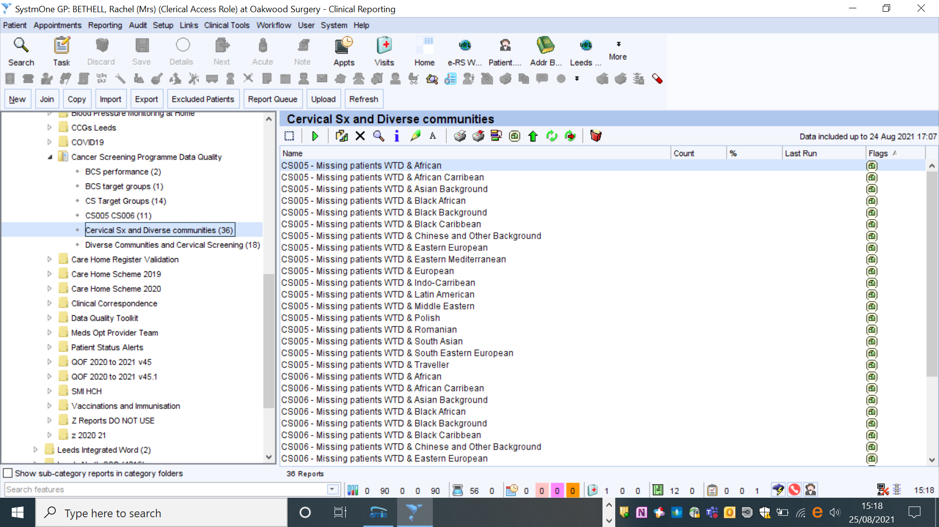

EMIS
Age 25-49
Leeds CCG Resource Publisher; Leeds Data Quality; Cancer Screening Programme; Cervical Cancer Screening; diverse communities CS005
Age 50-64
Leeds CCG Resource Publisher; Leeds Data Quality; Cancer Screening Programme; Cervical Cancer Screening; diverse communities CS006

