Guidance for Leeds Primary Care General Practices on EMIS Bowel Cancer Screening Template and Reports

Table of Contents
Bowel Cancer Screening Programme 2
Bowel Cancer Screening Template 3
Bowel Cancer Screening Read Codes 4
Bowel Cancer Screening (BCS) Reports 5
Exclusion Criteria 6
Bowel Cancer Screening Resources 6

Bowel Cancer Screening Programme

This guidance document has been created to identify the resources and tools available for practices participating in the bowel cancer screening programme. The below timeline provides a simplified overview of the bowel cancer screening process and identifies where practice participation is required:
Advice given about bowel cancer screening programme
The programme hub will offer bowel cancer screening tests directly to patients aged 60-74, if they have not received a kit they can request one by ringing 0800 707 60 60. Prior to this contact GP practices will need to provide patients with information about the bowel cancer screening programme in the month before they turn 60

To do this GP Practices will need to run a monthly report to identify patients that are due to turn 60 in the next month (go to page 5 for report info/location). Once these patients have been identified and the information has been provided to the patient, the practice should add ‘Advice given about bowel cancer screening programme’ (8CAy) to their record.

No response to bowel cancer screening invitation
Once the hub has invited a patient to complete their bowel screening kit they will wait 13 weeks for a response. If the kit is not returned/the patient does not respond to their bowel screening invitation they will be counted as a ‘non-responder’ by the hub. The hub will notify the practice by sending a pathology report through the links which will add the Read code ‘No response to bowel cancer screening programme invitation’ (9Ow2)’ to the patients record

Practices contact non-responders to complete bowel cancer screening
Once a patient has been identified as a ‘non responder’ you will need to contact the patient and invite them to complete their bowel cancer screening kit, this should be done by one of the following; telephone invitation, letter invitation, SMS invitation or face to face. Please note patients should be invited to complete screening 3 times (one per month).
A work to do report has been created to help practice identify this cohort of patients. Please go to page5 for report info/location. Please note, once a patient has completed their screening they will be removed from the WTD report

Bowel cancer screening declined
If a patient no patient no longer wants to participate add the ‘bowel cancer screening declined’ 8IA3 Read code to the patients record. Please note, if a patient does not respond after 3 contact attempts, wait 2 weeks and then add the ‘bowel cancer screening declined’ code to the patients record. (Resulting in 2 years opt out and excluding them in the Work To Do reports).

Bowel Cancer Screening Template

The bowel cancer screening template is called ‘Bowel Cancer Screening Advice/Contact HCH’, the template includes Read codes used for reporting, SMS examples and useful web links to provide further guidance and information to champions and patients. The template will need to be downloaded from the CCG extranet and imported into your clinical system; there are other resources such as the pre-60, Follow up letter and third party kit which will also need to be downloaded. To download these resources please click on the below hyperlinks
Pre 60 Letter to Patient
Bowel Screening Follow Up Letter
Bowel Cancer Screening Easy Read Letter
Third Party Kit Request Letter
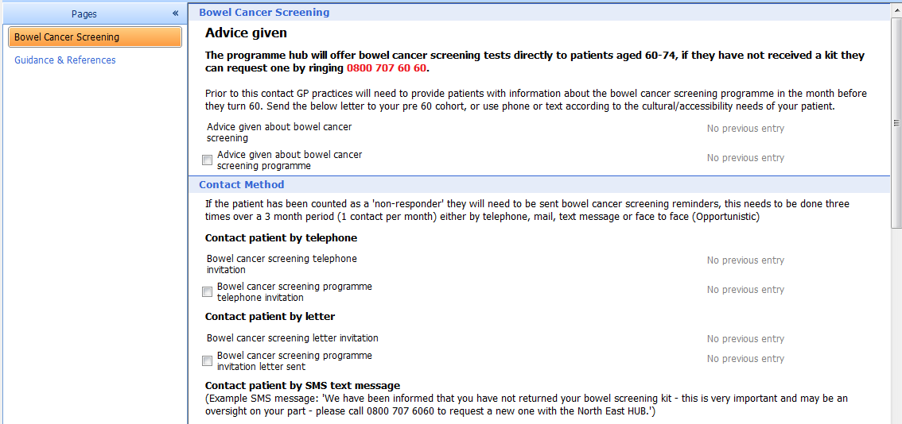
Template:
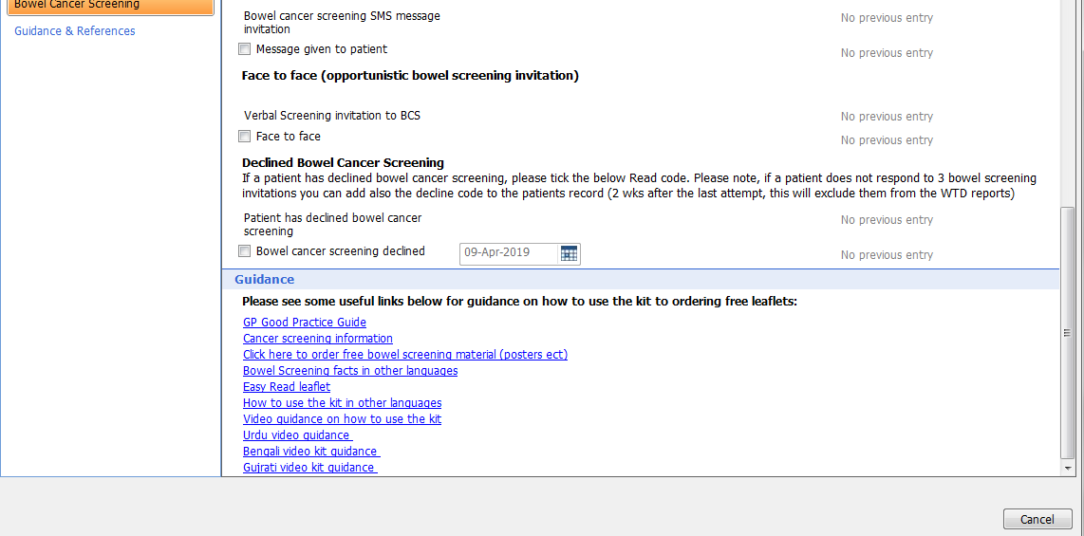

Bowel Cancer Screening Read Codes

The Read codes identified in the below table have been incorporated within the clinical template they will also be used in the reports to help support the programme evaluation:
SystmOne Read Code | Description
8CAy | Advice given about bowel cancer screening programme  - Use for any pre 60 contact to confirm that patient has been given information
9Ow4 | Bowel cancer screening programme telephone invitation
9Ow5 | Bowel cancer screening programme invitation letter sent
9N37 | Message given to patient  - Use this Read code when patients are contacted by SMS text
9O23. | Verbal invite to screening (face to face invitation)  - Only use if you have given specific face to face advice to patient about bowel screening completion.
8IA3 | Bowel cancer screening declined  - If no response after 3 attempts, wait 2 weeks then use this code  - Or if patient no longer wants to participate ( Resulting in 2 years opt out and excluding them in the Work To Do reports)

Please ensure that the correct Read codes are used, failure to use the Read codes suggested as part of the programme will have an impact on the reports pulled for your practice.

Bowel Cancer Screening (BCS) Reports

Performance Reports
Location: Reporting > Population Reporting> Health Care Hub > Bowel Cancer Screening
The following performance reports will be used for the programme evaluation:
-Performance -Number of eligible patients who have not responded to bowel cancer screening
-Performance -How many patients were consequently contacted by the practice to encourage completion of screening?
-Performance - How many patients contacted went on to complete bowel screening?

Work To Do Reports

Location: Reporting > Population Reporting> Health Care Hub > Bowel Cancer Screening > Work To Do
1) Patients due to turn 60/excluding patients that are not eligible: This report should be run monthly. Patients that are identified within this report should be sent a ‘Pre 60 letter’ (available within the template) with the ‘Advice given about bowel cancer screening programme’ Read code added to their record
2) WTD - Non-responder, without any contact codes, without BCS result: This report will help identify patients that have NOT been contacted /invited to complete BCS by the practice. Patients within this report should be invited to complete bowel screening three times either by SMS, telephone, letter or face to face (see required contact Read codes below):
-Bowel cancer screening programme telephone invitation (9Ow4)
-Bowel cancer screening programme invitation letter sent (9Ow5)
-Message given to patient (SMS Message) (9N37)
- Verbal invite to screening (9O23.)

3) WTD - Non-responders, that have been contacted by the practice but do NOT have a BCS result recorded: This report will help identify patients that HAVE been contacted/invited to complete BCS by the practice, however have not gone onto complete screening. Breakdown this report to assess how many times a patient has been invited (patients should be contact 3 times by the practice).

Exclusion Criteria

CRUK Review lists to exclude patients for whom it may be insensitive for the practice to endorse in screening. However, please note they will still be invited by the national screening programme:
-Colonoscopy in the last 2 years
-Opted out of screening/bowel cancer screening declined code recorded in the last 2 years
-Palliative
-Bowel cancer
-Chronic inflammatory bowel disease
-Are coded as ineligible

Bowel Cancer Screening Resources

CRUK GP Good Practice Guide: http://www.cancerresearchuk.org/health-professional/screening/bowel-screening-evidence-and-resources/bowel-screening-resources#BowelScreeningResources0

CRUK publications website where you can order free material:
https://publications.cancerresearchuk.org/taxonomy/term/4216
PHE bowel screening facts: https://www.gov.uk/government/publications/bowel-cancer-screening-benefits-and-risks

PHE Bowel Cancer screening kit: how to use instructions:
https://www.gov.uk/government/publications/bowel-cancer-screening-kit-how-to-use

NHS leaflet “A easy guide to bowel cancer screening” This leaflet uses illustrations to explain the bowel screening test and is a leaflet by and for people with learning disabilities/for those where English is their second language https://assets.publishing.service.gov.uk/government/uploads/system/uploads/attachment_data/file/598296/easy_guide_bowel_cancer_screening.pdf

Public Health new leaflet order form: https://www.leeds.gov.uk/phrc/resources/leaflets-and-posters PHRC supply the LCC/NHS leaflet “These 3 items could save your life” and the CRUK leaflet “Know your body spot cancer early”

How to use the kit, Dr Rob Eastham video http://www.facebook.com/screeninginfo

Links to videos promoting bowel screening and addressing some of the barriers to take up with the Asian community:
https://www.youtube.com/watch?v=P1Ry1zXIjkA (Urdu)
https://www.youtube.com/watch?v=CHIvdwOqrQs (Bengali)
https://www.youtube.com/watch?v=KOcI7-oN4DY (Gujrati)

