Staff training
Having a good understanding of the cancer screening programmes will allow staff to feel more confident in engaging in opportunistic conversations. The CWL team delivered training around the three cancer screening programmes. This training was recorded and is now available to view as part of the Cancer Wise Leeds resource package available on the Leeds Cancer Programme website, alongside a range of other resources, as part of the CWL legacy.

The resources and training slides provide an oversight of the screening programmes and an awareness of where to signpost patients for more information.

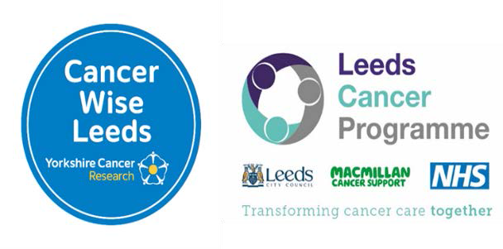
Opportunistic conversations – talking to patients about cancer screening
Opportunistic conversations can be a good way of engaging patients in talking about cancer screening. Conversations can be targeted and personalised, giving the patient the chance to ask questions. See the below recommendations on how to do this.
Placing alerts on patient records

Placing an alert on a patient’s record allows all staff in the practice to see that the patient is due their screening. This allows staff to have opportunistic conversations with that patient, for example when making an appointment with a GP for something else.

Vaccination clinics
Cancer Wise Leeds (CWL) Coordinators attended COVID clinics to raise awareness of cancer screening through opportunistic conversations with patients. Screening information cards (available as part of the CWL resource package) were handed out alongside COVID leaflets and Coordinators talked to patients as they waited after their vaccination.

As well as raising awareness, the Coordinators gained valuable feedback and insight into some of the barriers faced by patients when accessing screening. This type of information can enable practices to consider what they can do to remove these barriers.

Similar success and information can be gained through opportunistic conversations and distribution of resources at other clinics such as women's health, wound and flu clinics as well as at vaccination clinics going forward.

Key dates for opportunistic conversations

Cervical Cancer Prevention Week

World Cancer Day

Ovarian Cancer Awareness Month International Women’s day

Bowel Cancer Prevention Month

Cervical Screening Awareness Week Pride Month

Leeds Pride
January
February
March
April
June
August
September
October
November

Prostate Cancer Awareness Month

Breast Cancer Awareness Month

Lung Cancer Awareness Month Transgender Awareness Week

