**Bowel Screening Call for a Kit Clinic Report**

**Author: Zobi Barok, Screening and Awareness Coordinator, Cancer Wise Leeds**

**Context**

Cancer Wise Leeds Coordinators established a bowel screening pilot in June 2021. One practice took part in this pilot to increase participation in bowel screening. This report gives an overview of the pilot, results recorded and the recommendations of the model.

**Background**

The Call for a Kit Clinic (CFAKC) was an initiative set up in Lancashire that increased bowel screening coverage. The initiative presents a new approach that aims to breakdown barriers to participation using a person-centred approach:

**The following resulted from the Lancashire model:**

* **Success in engaging non responders with screening**
* **Increased practices’ coverage rate**
* **Increased knowledge of bowel screening among practice staff, who could then support patients on an ongoing basis**

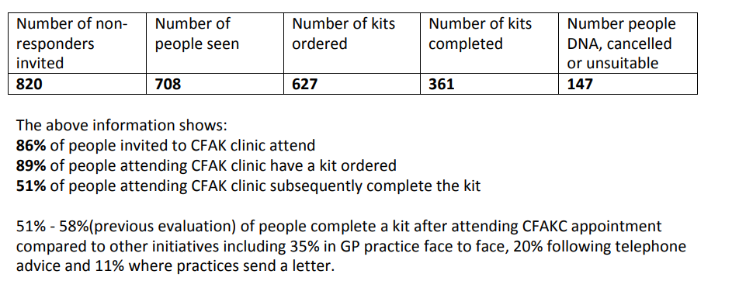

Cancer Wise Leeds (CWL) wanted to pilot a similar initiative in an area with low screening uptake in Leeds. The practice running the pilothad low bowel-screening uptake and decided to run the trial.

**Data Collection**

Three documents were disseminated to the bowel screening champions to capture the work from the pilot:

* **A telephone log** (*Appendix A*) – logging the number of calls made, the number of appointments made and reasons for decline (Step 1)
* **Patient evaluation** – measuring patient knowledge, confidence and awareness of bowel screening (Step 2)
* **Clinic log** – the number of kits ordered, understanding reasons for non-completion if a kit has been ordered; logging comments and patient consent, number of kits completed (Step 3)

**The Pilot**

The pilot practicehad some crossover working from a screening champion (based at another practice), who supported the clinic with her bilingual skills in Urdu/Punjabi.

The Bowel Screening Champion supporting the pilot practicecompleted both cohorts of the CFAKC on the following dates. Week 1 involved sending an invitation by letter; week 2 the patient was called and invited over the phone and week 3 is when the face-to-face clinic took place.

**Clinic 1:**

|  |  |  |  |
| --- | --- | --- | --- |
| **Week** | **Date** | **Time allocation** | **Task** |
| 1 | June 10 | ½ day | Sending out letters |
| 2 | June 17 | ½ day | Calling patients |
| 3 | June 24 | Full day | Face to Face Clinic |

**Clinic 2:**

|  |  |  |  |
| --- | --- | --- | --- |
| **Week** | **Date** | **Time allocation** | **Task** |
| 1 | Sept 14 | ½ day | Sending out letters |
| 2 | Sept 21 | ½ day | Calling patients |
| 3 | Sept 28 | Full day | Face to Face Clinic |

It was found that patients didn’t feel the need to attend the practice for a face-to-face clinic and were willing to engage through telephone intervention (week 2). During the second cohort, the practice confirmed that telephone interventions was best suited for this clinic.

**Results**

See Appendix B for table of results for the Pilot Practice.

* After sending letters and making phone calls, it was felt that the telephone intervention best suited this practice. Overall patients were accepting of kits being ordered on their behalf.
* Many of the patients were unaware of bowel screening and the importance of it. Around 60% had no knowledge of screening and the importance of it.
* During Cohort 1, 35 patients were contacted, of which 10 conversations were made. 3 kits were ordered and 2 were completed.
* The screening champion’s experience of Cohort 2 was much better, in terms of successful contact. Approximately 40 patients were contacted, of which 20 conversations were made. 12 kits were ordered and 8 were completed. Two patients had already completed their kits a year ago (records were not updated). The bowel-screening champion stated that having the ability to order kits directly from practice systems, eased the process for patients, rather than leaving the responsibility to patients to contact the bowel screening hub.

**Feedback from Cancer Screening Champion**

**“**I spoke to many of the patients from the list who said they would be happy to complete the kit, had they known about bowel screening”.

“I found the second cohort a much better experience as contact numbers were correct, making it easier for me to carry out telephone interventions”

“Many patients I contacted were from a South Asian background where English was not their first language which enabled me to converse with them in a language they understood and [gave them] a feeling of confidence”

**Recommendations**

The Call for a Kit clinic model has proven successful in other areas of the country and helps with limitations caused by the pandemic and pressures on Primary Care (staff sickness and shortages). The pilot recommends the following actions:

* Pilot to be taken up in other areas where there is evidence of low uptake in practices
* Contact practices who initially committed to running the pilot but cancelled due to staff capacity and sickness.
* Raise further awareness of screening within communities with low participation through targeted work (culturally diverse communities)
* Give the pilot more time before evaluating
* Review whether this engagement model could be used with other screening programmes.

|  |
| --- |
| **What is the anticipated outcome and impact of the activity for staff/patients?** |
| * Increased awareness of bowel cancer screening * Increased confidence about benefits of bowel cancer screening * Increased staff awareness of barriers of screening * Ordering new bowel kits for patients * Increased uptake in bowel cancer screening in the most deprived areas of Leeds * Increased uptake in bowel cancer screening with the lowest uptake practices in Leeds * Understanding if face to face conversations with patients increases bowel screening uptake * Evaluations from patient, screening champions and practice re clinics * Report providing outcomes * Recommendations for city wide implementation |

**Appendix A – Call Log to make appointments**

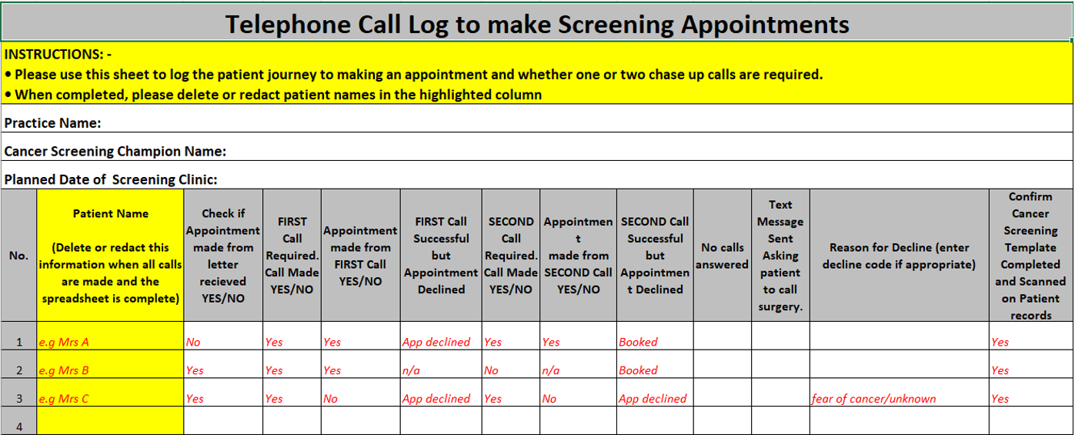

|  |  |  |  |  |  |  |  |  |
| --- | --- | --- | --- | --- | --- | --- | --- | --- |
| **Results of Pilot** | **No. of non-responders contacted** | **No. of successful telephone Interventions** | **Numbers seen face-to-face** | **No. of kits ordered** | **No. of kits completed** | **Issues arisen** | **Outcomes** | **Learning** |
| **Pilot Practice** |  |  |  |  |  | Contact details for non-responder not up to date | Screening champions had more confidence contacting cohort 2 as contact details were accurate | Telephone interventions were well received and the fact that the champion was bilingual made the calls feel more personalised |
| Cohort 1 | 35 | **10** | 0 | **3** | 2 |
| Cohort 2 | 40 | **20** | 0 | **12** | 8 |

**Appendix B – Results of the Pilot**